How to choose Data base Technology

Integration Consideration – systems to integrate together. Apache Spark, SQL interface, etc.

Scaling requirements -> Scaling up. MongoDB or HBase. Scale Horizontally, Transaction Rates. Big Websites, a lot of webservers, a lot of sites. U need to be looking at NoSQL

Support Consideration Think about security system. Retrieve into the data.

Budget Consideration.

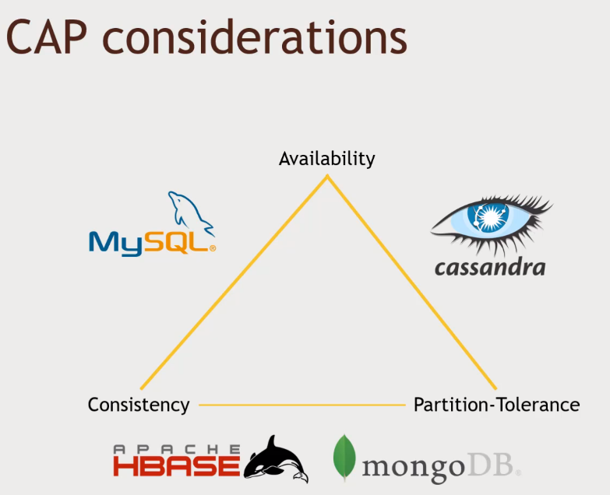Simplicity.

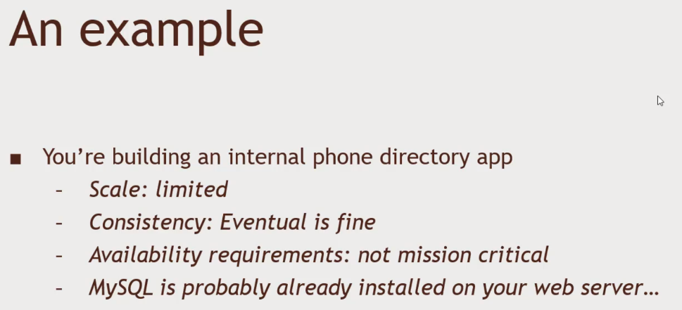Examples

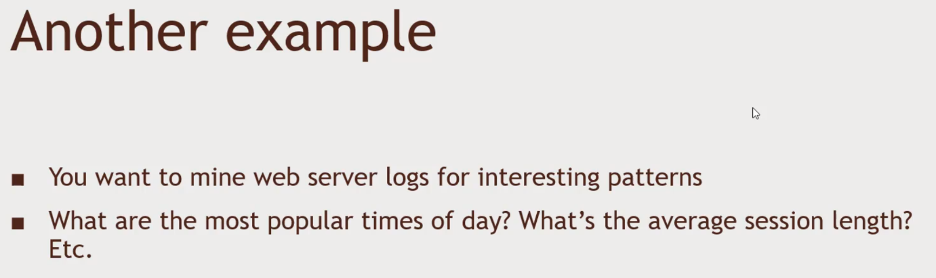MySQL

Do I have enough Scale, No High Transaction rates. Spark, Hive, Pig, Tableau.

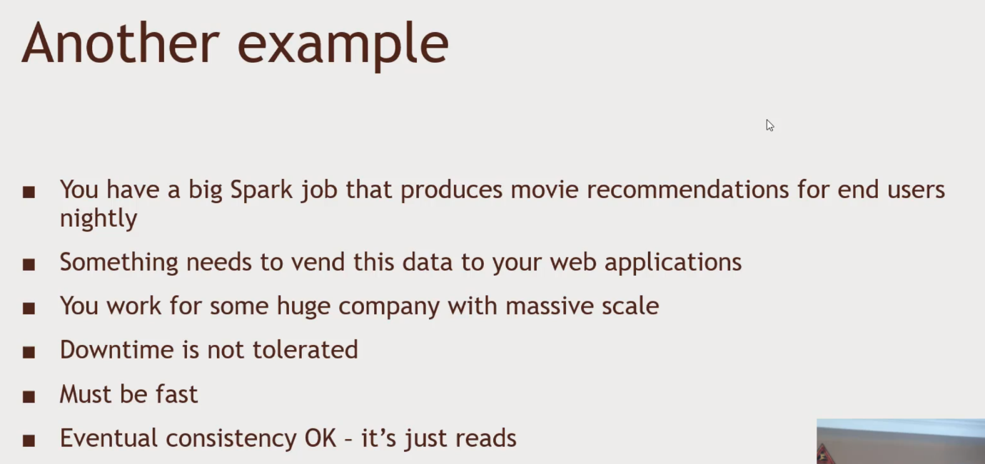Movie Recommendation. Computing offline is acceptable. Cassandra.

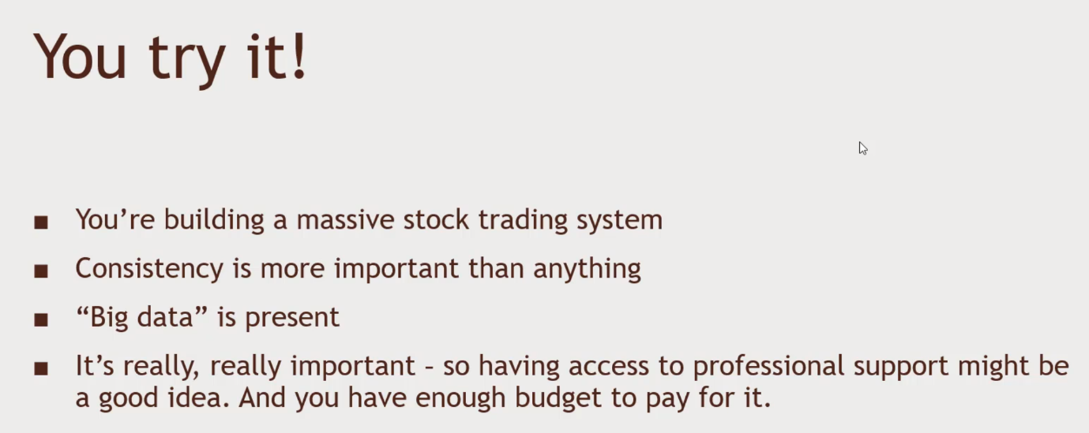MongoDB. High Single master. All the application clients.

HBase vs MongoDB. Strong external support, MongoDB is better because they have a big company that does MongoDB.